18. Adding Thumbnail to page in AEM

Steps to be followed:

1. Go to sites console (<http://localhost:4502/sites.html/content> )
2. Select your project and click on view Properties as shown below.

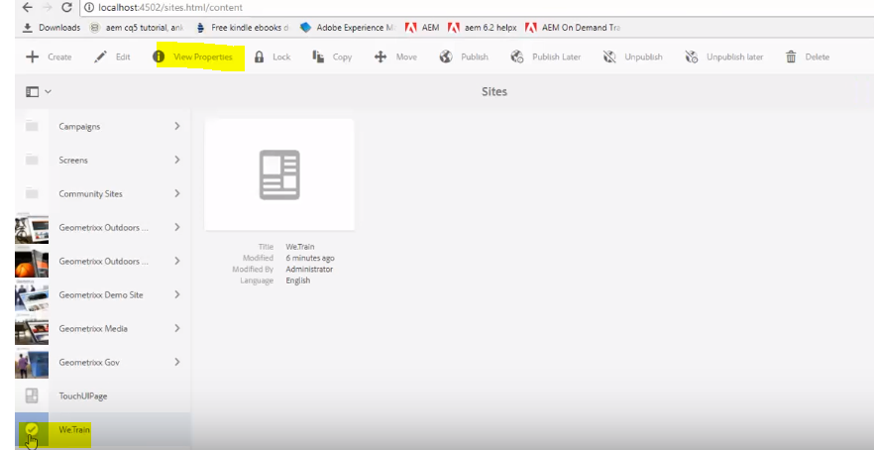

1. Go to THUMBNAIL tab and click on upload image button and select your image. Save the changes.

